**Name:­­­­­­­­­­_________________________ Date:__________________**

**Wizard of OZ Comparison**

**Book**

**Movie**

**Name:__________________________ Date:______________**

**Day in the Life of 1900 School**

**-What is a 1900 classroom like?**

**-What resources did the students have? The teacher?**

**-How would you like going to school in the 1900’s? (Explain in detail)**

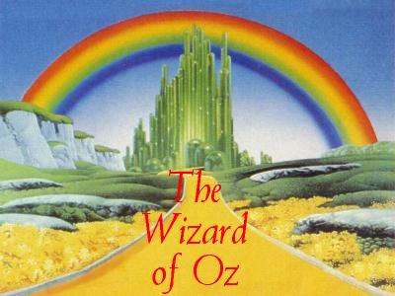

**Name:_____________________ Date:________________**

**Favorite Character**

**(Draw the character and use colors)**

**Character Traits: (describe what there like, how they treat others..)**

**What would YOU like the Wizard to give you, if you could meet him?**

**Story as the Main Character-**

**-State the strange land you will travel,**

**-The way you got there (tornado),**

**-Describe all of the unusual people**

**-and the interesting things you do while your there.**

**Pictures:**

http://www.google.com/imgres?q=wizard+in+the+of+oz&hl=en&client=firefox-a&rls=org.mozilla:en-US:official&biw=1016&bih=673&tbm=isch&tbnid=u0TuJoJlvZZrkM:&imgrefurl=http://www.uktheatretickets.co.uk/shows/The-Wizard-of-Oz-Tickets&docid=3XOd2RxBsKbtTM&imgurl=http://www.uktheatretickets.co.uk/images/wizardofoz/wizard-of-oz-illusionist.jpg&w=768&h=576&ei=UZ3GTpX4I8PIgQfQrO1a&zoom=1&iact=rc&dur=283&sig=112004411835734656511&page=3&tbnh=140&tbnw=159&start=28&ndsp=14&ved=1t:429,r:0,s:28&tx=68&ty=18

*http://www.google.com/imgres?q=wizard+of+oz&hl=en&client=firefox-a&hs=ds8&sa=X&rls=org.mozilla:en-US:official&biw=1016&bih=673&tbm=isch&prmd=imvnsub&tbnid=nhrBXzJPdmoaYM:&imgrefurl=http://www.stage212.org/oz/oz.html&docid=KaK_eAsuz71TSM&imgurl=http://www.stage212.org/oz/oz.gif&w=400&h=300&ei=0pnGTs_dFIKCgAfg28VJ&zoom=1&iact=rc&dur=619&sig=112004411835734656511&page=1&tbnh=119&tbnw=159&start=0&ndsp=17&ved=1t:429,r:8,s:0&tx=38&ty=57*

Name:____________________________

Date:___________________________

**“If I only had a brain…”**

What would you want if you got the chance to meet the Wizard? Explain why.

**Scarecrow Rubric**

Has the student followed directions

1 2 3 4

Has the student stayed on task

1 2 3 4

Did the student work independently to complete the scarecrow

1 2 3 4

**Tin Man Rubric**

Has the student followed directions

1 2 3 4

Has the student stayed on task

1 2 3 4

Did the student bring in proper materials for the assignment

1 2 3 4

Did the student show creativity while creating their artwork

1 2 3 4